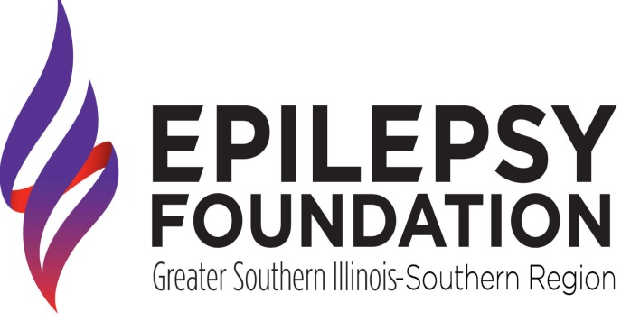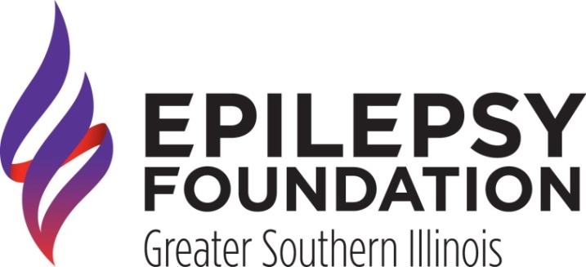

and

**Presents the November 2022 Educational**

**Support Group**

**Activity: Learn All About Seizure**

**Tracking and Reporting!!!**

**Where: Epilepsy Foundation of Greater Southern Illinois Office**

**3515 North Belt West**

**Belleville, IL 62226**

**When: November 15, 2022**

**10:00am to 12: 00pm**

***Snacks and beverages will be provided at the office.***

***Please RSVP to Elizabeth Daniels at***

***(618) 236-2181 ext. 109***

***or*** [***elizabethd@epilepsygsil.org***](mailto:elizabethd@epilepsygsil.org) ***before, November 8, 2022.***

**Sponsored by the St. Clair County Mental Health Board, Madison County Mental Health Board, and the Illinois Department of Human Services.**



