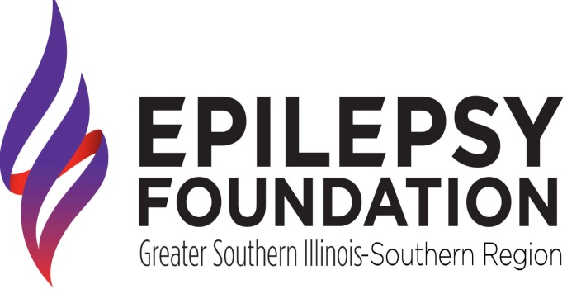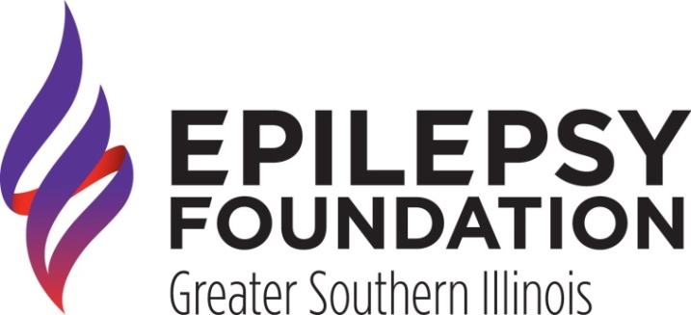

and

**Presents the October 2022 Caregiver**

**Support Group**

**Activity: Caregiving and Activities**

**in the Community**

**Where: Epilepsy Foundation of**

**Greater Southern Illinois**

**Office**

**3515 North Belt West**

**Belleville, IL 62226**

**When: October 4, 2022**

**10:00am to 11:00am**

***Snacks and beverages will be provided.***

***Please RSVP to Elizabeth Daniels at***

***(618) 236-2181 ext. 109***

***or elizabethd@epilepsygsil.org before September 30, 2022.***

**Sponsored by the St. Clair County Mental Health Board, Madison County Mental Health Board, and the Illinois Department of Human Services.**

